# **Computer Science**

**Name** : Sangam Shrestha

**Class** : 12

**Subject** : Computer Science

**Roll No** : 48

**UNIT 1. Database**

Data: Data are the collection of raw facts and figure which are unorganized, uninterpreted, and isolated, which doesn’t give any particular sense. They are randomly gathered. So that they can be processed to obtain the desired result.

Ram, 17, Pokhara, 18

Information: Information are the processed form of data. Information gives a meaning full result after data are interpreted.

Ram 17 year old and lives in Pokhara 18.

As we know, very organization from the prehistoric time deals with data and information. Data are very necessary for organization to operate. In previous time, data used to be collected randomly and were not organized in any particular order which leads to following drawbacks.

Some information was stored in more than one file. (Data redundancy).

Difficult to present data from the user’s view.

Data security was one of the major problem.

Data processing and manipulation were difficult.

Data retrieval were very slow.

Hence, concept of database arise in order to overcome the above drawbacks or limitations. Database is collection of interrelated data or entities stored in tabular form. It gives very useful information for an organization during data manipulation and decision making. It provides a base for foundation for managing large volume of data in a well organized manner. Simply database is a systematic and organized form of data so that user can retrieve or access data whenever required within no time. For eg, telephone directory, dictionary, marks ledger, customer records etc.

In past people used file processing system / flat file system in order to store data and keep record due to difficulty in processing file and having following limitations. This system are no longer in use rather people use DBMS in to order Keep record systematically, scientifically and securely.

**Limitations of flat file system:**

* Data security system is one of the major problem in flat file system.
* Data Sharing was almost impossible or difficult.
* Some record was stored in more than one file. (Data redundancy)
* Difficult to represent data through user prospective.
* It is difficult for processing complex queries.
* DBMS (Database Management System)

**DBMS (Database Management System)**

DBMS is a computerized record keeping system. It is a software that defines, manipulates and manage the database. It allows to access the file, update the record and retrieve data as requested. In other word, DBMS is defined as the collection of interrelated data and set of programs to access there data. The collection of data is usually a database which contains the information about any particular organization. The primary goal of DBMS is to provide an effective and efficient environment for both data retrieval and storing data in database. For example MS Access, Oracle, MY SQL, Fox-Pro, D-base etc

**Advantages of DBMS:**

1) Sharing data: Using DBMS, data stored in database can be shared among multiple users or computer. For example, branches of bank share data from database.

2) Reduce data redundancy: Data redundancy refer to duplication or repetition of same data over and over. DBMS reduces such type of unnecessary repetition of data.

3) Data backup and recovery: Using DBMS, we can easily create spare copy of original files and documents that can be later used in case of accidental or intentional loss and damages.

4) Data security: Using DBMS we can restrict use of database to the unauthorized person. It helps to ensure date security.

5) Multiple user interface: DBMS facilitates sharing of data which means same data can be accessed from multiple device and location. Hence, user can experience multiple interface to access same set of data.

6) Data Integrity: Data Integrity refers to consistency of data. Using database we can arrange same sort of data in a like order. We can define and enforce constraints for data integrity.

**Disadvantages of DBMS:**

1) Expensive: It may be expensive to run and operate DBMS for any organization.

2) Changing Technology: It is very much difficult to incorporate latest changing technology in existing system. In order to create and maintain database technical manpower and trainings are required.

3) Backup is needed: Since data maybe damage anytime accidentally or intentionally. So, it is mandatory to create a backup.

**Database Model**

There are different forms of Database Management system. Each characterized by the way where data are defined and structured. This arrangement of data in several structure are known as data base model. Different types of database model.

**Hierarchical database model**

It is one of the oldest type of database model. In this model data are represented in the forms of record, each record has multiple field or attributes. All records are arranged in database as tree like structure. The relationship between the records is called parent child relationship in which one child record relates to only a single parent i.e child posses property only property of a single parent. Here child are restricted to use the property of a parent to whom it doesn't belong.

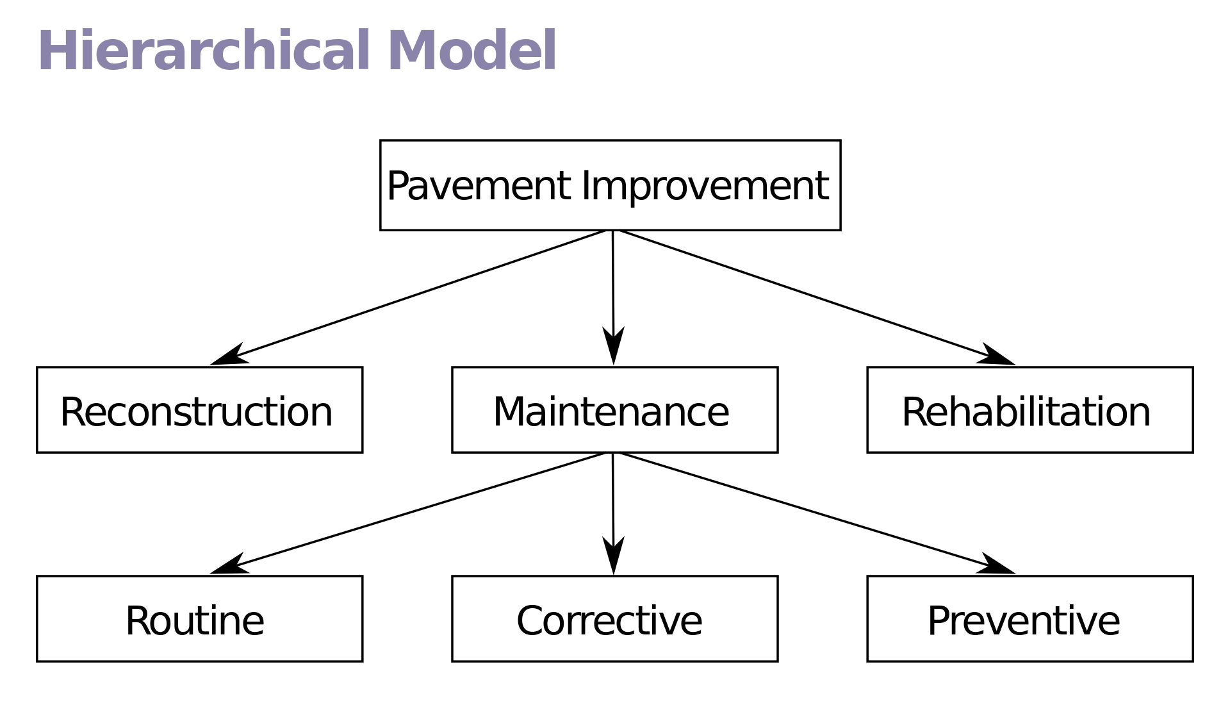

**Advantages**

* It is the simplest and the easiest model.
* It supports one to one or one to many relationship.
* Searching is easier and faster if parent is known.

**Disadvantages**

* It is an old fashion and outdated database model.
* It doesn’t support many to one relationship.
* It doesn’t reduce data redundancy because some data are written over different places.

**Network database model**

This network model replace hierarchical model due to some limitation on the model. Suppose an employee relates to two different department then hierarchical model cannot be able to arrange record in proper place. So, network database model was emerged to arrange non-hierarchical database. The structure of database is more like graph rather than tree structure. A network model consists of collection of record which are interrelated to each other with the help of relationship. Each records have multiple fields and each field has only one data value. In this type of model a parent may have multiple child, as well as child can have multiple parent.

**Advantages**

* It accepts many to many relationships. So, It is more flexible .
* It reduces data redundancy.
* This network mode is simple and easy to design.
* Searching is faster due to use of multi-directional pointer.

**Disadvantages**

* Needs long program to handle the relationship.
* Lack of structural independence.
* Less security

**Relational database model**

In relational database model, the data are organized into tables which contains multiple row and columns. These tables are called relations. A row in a table represents a relationship among a set of values. Since, a table is collection of such relationship. It is generally referred to the mathematical term relations from which the relational database model derives its name. It is also known as RDBMS. Note: The database system which stores and display data in tabular format of rows and column like spreadsheet is known as RDBMS. It is the most practical DBMS those days. For example, MS-Access, MY SQL, Oracle etc

**Advantages**

* There is less data redundancy.
* Breaking of complex database into simple is very much easier.
* Database processing is faster than other model.

**Disadvantage**

* Establishing more relationships complex.
* It requires powerful computer and data storage device.

**Centralized database**

It is a simple type which works on client server basis. In this type clients or user are directly connected to the centrally totally located server. This server hosts the data of its client or user and helps them to store and retrieve data as requirement. This type of system are used in small scale industries which doesn't have to deal with large volume of data and user. Centralized database runs on single computer which may have single or multiple user. Since database is centralized, security is not a crucial part here. The maintenance of database is easier because of data are centrally stored. This type of system denote allow unauthorized person to access data.

**Advantages**

* Suitable for small scale industries.
* Operation and maintenance is easier.
* Since it prevent unauthorized person being accessed to database, it minimizes risk factor.

**Disadvantages**

* Data are not secured in this type of system.
* Not suitable for large scale industries.
* Failure of centrally located serves will collapse whole network.

**Distributed database**

This type of database system are complex in structure, instead of storing and retrieving data from centrally located server, it uses several numbers of database and server randomly located at different place. It is the collection of multiple logically interrelated database which are distributed in many geographical location. Since server are located at different locations user can experience a good speed of bandwidth. Similarly, back up and recovery process is lot more easier there, which makes data more secured. This type of system is used by large organization who has to deal with large volume of data and user all around the world. Since it is distributed in nature there may arises security issue and are costly to maintain and operate. Simply, distributed database system are the collection of several number of centralized database system in different locations.

**Advantages**

* Backup and recovery of data is easier.
* It can handle large volume of data and user all over the word.
* User can experience high speed bandwidth.

**Disadvantages**

* Very expensive to operate and maintain.
* Data security may be real issue.

**Differences between centralized and distributed database system:**

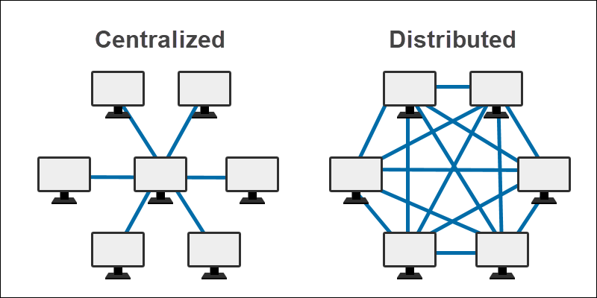

**Structure query Language (SQL)**

SQL stands for Structured Query Language. It is an international standard data base query language for accessing and managing data in the database. SQL was introduced and developed by IBM in early 1970’s. It was able to control relational database. SQL is not a complete programming language. It is only used for communicating with database. SQL has statement for data definition (DDL), data manipulation (DML) and data control (DCL). A query is a request to a DBMS for the retrieval, modification, insertion and deletion of the data from database.

SQL is made of three sub languages: DDL, DML and DCL

1) DDL (Data Definition Language): DDL is used by the database designer and programmers to specify the content and the structure of table. It is used to define the physical characteristics of record. It includes commands that manipulate the structure of object such as tables: For eg, to create table

Syntax:

CREATE TABLE table_name (field_name1 data_type1 field_name2 data_type2 ………);

CREATE TABLE Student (SN Number Fname text);

2) DML (Data Manipulation Language): DML is related with manipulation of records such as retrieval, sorting, display and deletion of records or data. It helps user to use query and display report of the table. It provide technique for processing the database. It includes commands like insert, delete, select, and update to manipulate the information stored in the database.

Syntax:

INSERT INTO table_name VALUES (list of values);

INSERT INTO student VALUES (1 RAM);

3) DCL (Data Control Language): All provides additional feature for security of table and database. It includes commands for controlling data and access to the database. Some of the example of this command are grant, commit, etc

**Entity Relationship Database model (ER Model)**

The entity relationship database model (ER diagram) is based on the perception of a real world that contains a collection of basic object called entities and relationship among these objects. The ER diagram is an overall logical structure of database that can be expressed graphically. It was developed to facilitates database design. The major objectives of ER diagram is to show relationship among different entities. It has following components.

1) Entity: The distinguishable object of this real world is known as entities. It has a set of properties which uniquely identifies an entity. For eg, if student is an entity then his/her name may be property. It is denoted by rectangle.

2) Attributes: Attributes are the properties possessed by an entity. They are represented by ellipse or oval sign. For eg, if student is an entity then its attribute can be registration number, name, roll no, class, address, etc.

3) Link: The flow of information is indicated by the link in ER diagram. It is simply denoted by a line. It is a connection of entity, attributes and relationships.

4) Relationships: A relationship is a association among several entities. It is represented by diamond. For eg, if teachers and students are two entities the association can be derived as teacher teachers students. It shows meaningful dependencies between several entities. There are 3 types of relationships. One to one. One to many, Many to many.

**DBA (Database Administrator)**

DBA is the most responsible person in an organization with sound knowledge of DBMS. He/she is the overall administrator of the program. He/she has the maximum amount of privileges for accessing database and defining the role of the employee which use the system. The main goal of DBA is to keep the database server up to date, secure and provide information to the user on demand.

**Qualities of good DBA**

* He/she should have sound and complete knowledge about DBMS and its operation.
* He/she should be familiar with several DBMS packages such as MS Access, MY SQL, Oracle etc
* He/she should have depth knowledge about the OS in which database server is running.
* He/she should have good understanding of network architecture.
* He/she should hove good database designing skill.

**Responsibilities**

* DBA has responsibility to install, monitor, and upgrade database server.
* He/she should has responsibility to maintain database security by creating backup for recovery.
* He/she has responsibility to conduct training on the uses of database.
* DBA defines user privilege, relationships and manages form, reports in database.

**Normalization**

The process of breaking down or decomposing as complex relation into simple relation. It reduces redundancy (unnecessary repetition of data) using principle of non-loss decomposition in which table are reduce to smaller tables without loss of information. Normalization is the database design process in which complex database table is broken down into simple separate tables. It makes data model more flexible and easier to maintain. EF Codd has introduced few rules for normalizing the database in 1970 and these rules are known as normal forms. This process minimizes and controls the duplication of data in a database and also provides a rapid search for data from database.

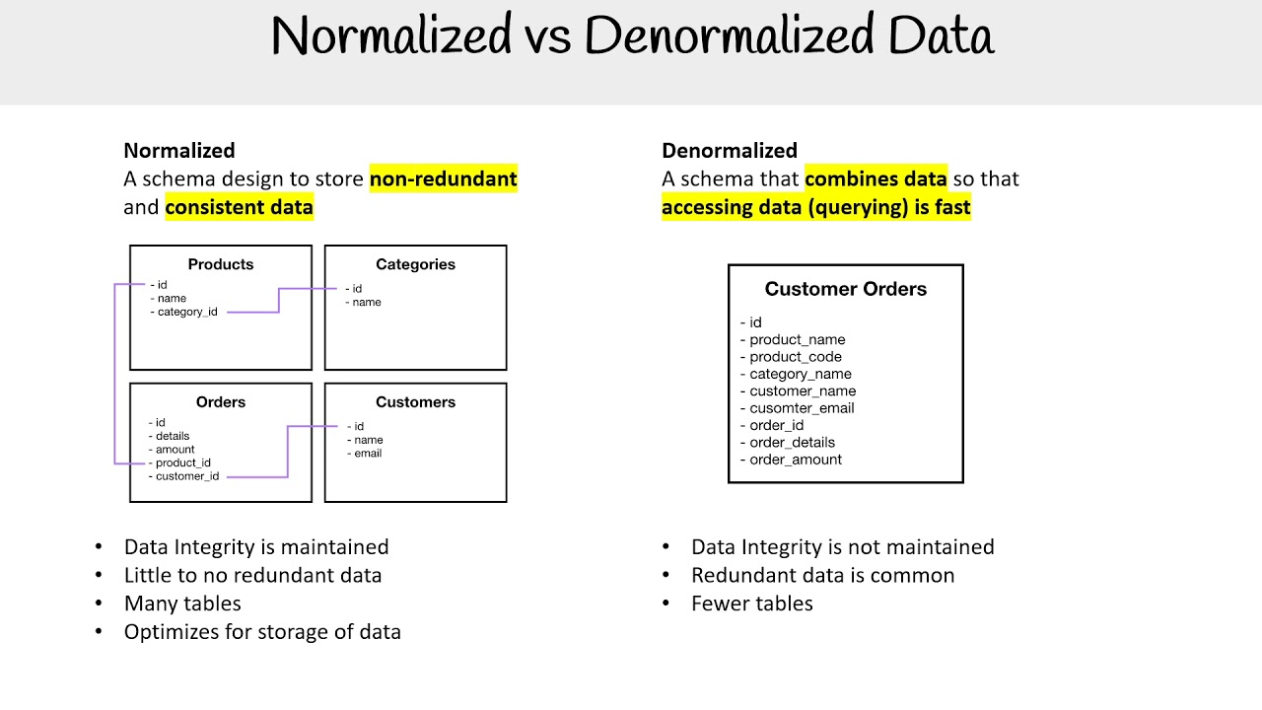

**Advantages of normalization**

* It reduces data redundancy (duplication of data)
* It improves faster sorting and indexing.
* It simplifies the structure of the database table.
* It improves the performance of a system.
* It avoids loss of information.

**Normal Forms:**

**A) 1NF ( First Normal form)**

* 1NF sets the very basic rules for on organized database.
* It eliminates duplicate columns from the same table.
* It creates separate tables from each group of related data and identify each row with a unique column called primary key.

The objective of 1NF is to divide the base datas into logical units called tables.

**B) 2NF (Second Normal form)**

* It further addresses the concept of remaining duplicate data.
* It should be in first normal form.
* It removes the date that applies to multiple row of a table and place them in separate tables.

The objective of second NF is to take data i.e. partly dependent upon the primary key and enter the data into another table.

**3NF (Third Normal Form)**

* It should be in second normal form.
* It removes the column that are not dependent on primary key using 3NF above table can be decomposed as:

**UNIT 2. Networking**

**Basic elements of communication**

* Sender (source) which creates the message to be transferred.
* Medium which carry message.
* Receiver (sink) which receives the message
* Data: The information or message to be carried.
* Protocol: Rules to carry the data.

**Communication System**

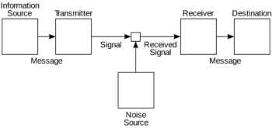

As we know, system refers to the integration of several individual units or components interacting with each other to achieve a common objective. Similar, to make an effective communication, we need several communicating unit which interact with each other. This integrated individual functioning components are called communication system.

**Modes of communication:**

* Based on the flow of direction of communication. Communication has 3 modes.
* Simplex: It is unidirectional mode of communication on which sender always sends the data and receiver receives it. In this mode receiver never sends the data. For example, radio, television
* Half duplex: It is the bidirectional mode of communication in which sender can send the data and receives the data as well and vice versa but only one at a time that means sender is not allowed to receive data while it is sending data. For eg, walkie talkie
* Full duplex: It is the bidirectional mode of communication in which both sender and receiver can send and receives data simultaneously. For eg, mobile phones, telephone etc

**Computer Network**

From the very beginning there is an emerging trend of making communication. People use computer to share different data and information at different location. Thus, the group of computer Interconnected with each other through any type of transportation media that may be either wired on wireless in order to share different hardware software and other resources is known as computer network. The concept of connected computer sharing resources is called Networking. We use different bounded media like twisted pair cable , coaxial cable and fibre optics cable or unbounded media like microwave, radio wave, infrared , satellites to establish connection between different computers at different location

**Advantages of computer network**

* Hardware sharing: Using computer network expensive hardware devices can be shared among multiple number of computers. For example, in cyber one printer can be shared among multiple number of computers which help to save money as well time.
* Software sharing: Similarly, software also can be shared among computer n a network which helps to access application program from any remote location.
* Centralized control and management: Network provides the centralized control and management that means every other computer in a network are centrally connected with server which controls and monitor all the activities within the network. This helps to ensure security
* Speedy and fast effective communication: Since all the computer in a Network are interconnected with each other, one can sends and receives messages within the computer in just few seconds.
* Backup and Recovery: Since all the computer are connected with server, it helps to maintain backup at periodic interval. that means keeping extra copy so that data and the formation can be recover when lost accidentally or intentionally.
* Flexible Access: In a network a computer can easily access files from other computer he/she has authority or privilege to access/use.
* Work group computing: Network allows different user to work in group that means; different user can work on o single task by dividing work load.

**Disadvantage of computer network**

* Virus Transfer: Since computer Network allows data and information to be transferred , still there remains the possibility of virus transfer and other malicious program.
* Less reliable: Since computer in a network are inter connected with each other performance of one computer may affect performance of another computer. That means if one computer start malfunctioning in a network than it may affect another computers in a network.
* Security: Computer network is a group of computer interconnected with each other. That means, one computer in a network can access data and information from other computer. Since there may be also possibility of unauthorized access there exist security issue in a network.
* Expensive: Creating a network among different computer is itself a complex task or job. We may need different inter networking devices and others special devices and other to establish a network. Buying all the devices, cables and equipment may be expensive.
* Need Technical Manpower: Since establishing a network is a Technical job we need a technical manpower in order to establish and trouble shoot a network. Hiring technical manpower may be expensive.

**Type of Network**

**On the basis of geographical area covered**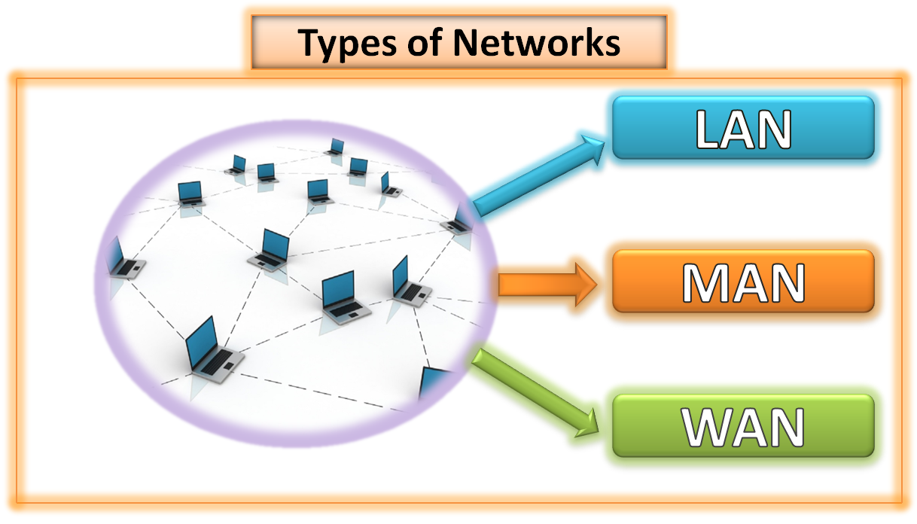

* **LAN**
* **MAN**
* **WAN**

**On the basis of network architecture**

* **Peer-to- peer**
* **Client server**

1) **LAN**: LAN stands for Local Area Network. It is the type of Network which covers small geographical area such as room, building, school, university etc. Since it covers small area, are interconnected with guided or wired media such as twisted pair cable, coaxial cable or fibre optic cable. It is one of the fastest network in term of transmission speed among all other. Since, they are connected with wires they have higher reliability. Some of the implementation of LAN can be in computer lab, cyber, network between different department.

**Advantages of LAN**

* It is cheaper to establish.
* Data transmission is faster than MAN and WAN.
* It has higher security to resources of the network
* It is eager to establish, manage es of the network and operate

**Disadvantages of LAN**

* It is limited only to a small area.
* It can connect less number of computers comparatively.
* Cannot be used as distributed network.

2) **MAN**: MAN stands for Metropolitan Area Network. It covers an entire city, district or village. MAN connects two or more than two LAN together. Big companies like banks, and many organization have their branches or sub offices in a city or in neighboring city use MAN to connect with each other. The communication media in MAN can be guided as well as unguided. This network use bridge, repeater, router, switch etc to establish a connection. The data transmission speed of MAN is faster compared to LAN and slower to thot of LAN. Media like microwave, radio wave, infrared etc are used to connect devices in a MAN.

**Advantages of MAN**

* It covers larger geographical area than LAN.
* It can connect large number of computer than LAN.
* We can use guided as well as unguided type of transmission media.

**Disadvantages of MAN**

* It is expensIve to set up then LAN.
* Transmission speed slower compared to LAN.
* It is complex to establish, manage and provides security.

3) **WAN**: It stands for Wide Area Network, which can be extended to the whole world. It is also known as the network of networks. They are used to connect LANs together so that users and computers in one location can communicate with users and computer in another location. WAN is unlimited. It is the slowest data communication among all of three as it covers entire country, continents or even a whole world. These type of network use unguided media such as microwave, radio wave, satellites and even fibre optics some times to communicate in larger distance. The best example of WAN is Internet which is a public network whereas Intranet is a private network earn by an organizations

**Advantage of WAN**

* It covers larger geographical area than LAN and MAN.
* It can connect large number of computer compared to LAN and MAN.
* Using WAN communication can be done over a large distance.

**Disadvantage of WAN**

* It is expensive to establish, manage and operate.
* It is the slowest type of network compared to that of LAN and MAN.
* Highly qualified manpower are required to establish and run these type of network.

**On the basis of Network architecture.**

**1) Peer-to-peer:** These type of network architecture in which all the computers in a network are connected with each other having equal access and responsibility are known as peer -to-peer network. In this type of network architecture there is no presence of main computer that is server which provides services to the network. All the jobs and task are carried out by themselves without having authority from other computer. Hence, they are known as peers. Each computer in a network behave itself as a client as well as server. This type of architecture can be used to small work group where security may not be of greater issue.

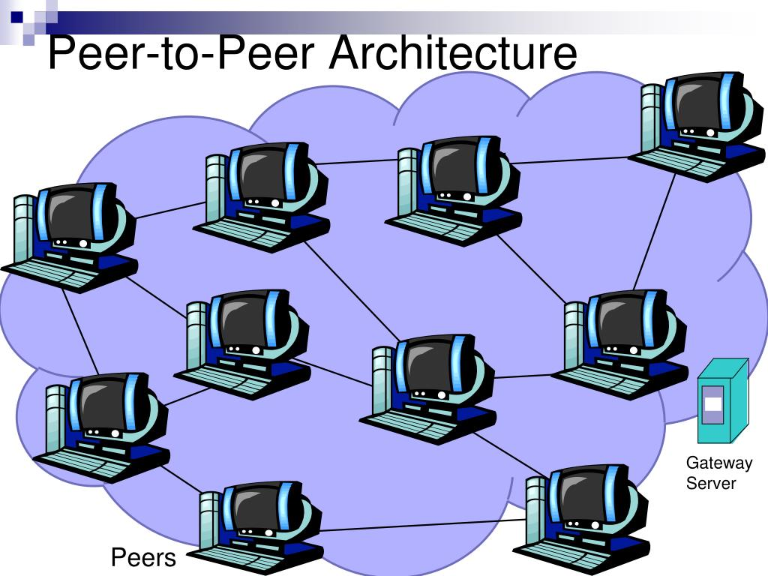

**UNIT 3. Web Technology II**

**Web technology with Server side and client side programming**

Web technology is the tools and techniques which enables two or more computing devices to communicate over a network i.e. Internet. Web Technology consist of two words, the web refers to the World Wide Web generally known as World Wide Web. WWW is the cyber space containing webpages, documents, and any other resources which are identified and located with the help of their URLs. Technology refers to the tools and techniques that makes these resources available on the Web such as, web browsers to view content of web, Programming languages and frameworks for the development of websites, Database to store data at back end, protocols for communicating on the web, multimedia elements etc.

Web development is the process of designing and developing website which are hosted through internet or intranet. The process of developing web can range from developing static page to a complex such as web based application social media sites, E-commerce. Web development includes web design, web content development, client side scripting, server side scripting, web engineering etc. Since, web development consists of several inter-related task which can be accomplish by different types of developer who focuses on different aspect of web creation.

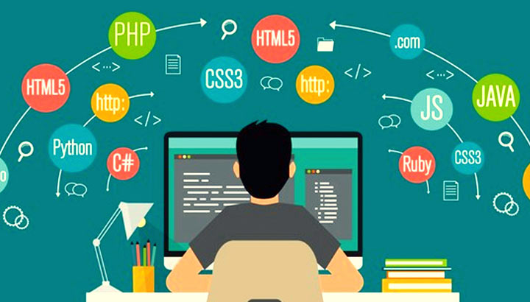

**Server side and client side programming:**

* **Client-Side Scripting programming:** Client-side scripting is performed to generate a code that can run on the client side i.e (front end) browser without needing the server-side (back end) processing. Basically, client-side scripts are placed inside an HTML document. The client-side scripting can be used to layout the content of the web. For example, when a user makes a request through web browser for a webpage to the server, it just sent the HTML and CSS as plain text, and the browser interprets and renders the content of web in the client end (user). Client-side scripting is designed to run as a scripting language which can be executed by web browser. Front end developer is someone who design and develop client side of a website. Generally. he or she works in user interface (UI) of a website. Front end developer must be at least fluent in three different languages i.e. HTML, CSS, JavaScript whereas, there are several other libraries which can be used for front end development.

**Server-Side Scripting programming:** Server-side scripting also known as back-end runs on the server where the application is hosted. Server-side is used to serve content depending upon the user request. Back end helps to create dynamic web based application that allows user to interact and communicate with the application. Back end language also helps to connect front end with data base. So that, User can store and retrieve data as per the requirement. Back-end developer is responsible for server-side programming. Some of the popular server-side (back-end) scripting language are ASP, JavaScript (using SSJS (Server-side JavaScript e.g. node.js), Perl, PHP, Ruby, Python etc.

Client-side scripting and server-side scripting both works along side. The client-side scripting emphasizes making the interface of the web application or website (UI) more appealing and functional. Whereas, server-side scripting emphasizes on data accessing methods, error handling and fast processing etc.

**Note**: Full-stack developer understand both Front end and back end development process. They can accomplish entire project. Full stack developer must have expertise in client site and server site Scripting language. Moreover, he/she has a great knowledge of integrating database with the application.

**How to add JavaScript in web pages?**

**Inline JavaScript code:**

<HTML>

<HEAD><TITLE>Sample</TITLE></HEAD>

<BODY>

<BUTTON onclick = “alert(‘Your message’)”>Click me</BUTTON>

</BODY>

</HTML>

**Internal (Embedding) JavaScript code:**

<HTML>

<HEAD><TITLE>Sample</TITLE></HEAD>

<BODY>

<BUTTON onclick = “disp( )”>Click me</BUTTON>

<SCRIPT>

function disp( )

{

alert(“Your message”);

}

</SCRIPT>

</BODY>

</HTML>

**External JavaScript file:**

<HTML>

<HEAD><TITLE>Sample</TITLE></HEAD>

<SCRIPT src = “name.js”></Script>

<BODY>

<BUTTON onclick = “disp( )”>Click me</BUTTON>

</BODY>

</HTML>

**Uses of JavaScript:**

* JS is used for client-side validation.
* JS can be used to make dynamic drop-down menus.
* JS can be used to display date, time and even clock.
* JS can be used to generate pop-up windows, alert message, dialog box etc
* JS can also be used for Server application.
* JS can be used for cross platform mobile apps development.
* JS can be used for game development.

**Variables in JavaScript:**

Variables in JavaScript are declared by using keyword 'var'. for eg,

var a=3,b=4;

var fruit = "apple";

**Adding two number in JavaScript:**

<HTML>

<HEAD><TITLE>Addition</TITLE></HEAD>

<BODY>

<SCRIPT>

var a=3, b=2, c=a+b;

document.write(c);

</SCRIPT>

</BODY>

</HEAD>

**DDL DML and DCL statements**

**1) Data Definition Language (DDL)**

DDL is used by database designer and programmer to specify the content and the structure of table. DDL is used to define the physical characteristics of records in a database table. It includes command than manipulate the structure of object such as table. Some DDL statements are: CREATE, DROP, ALTER

**1.1 CREATE statement**

In order to create a database we can use CREATE statement as follows:

CREATE DATABASE database_name;

Eg,

CREATE DATABASE student;

The above statement will create a database with the name student.

In order to create a database table we can use CREATE statement as follows:

CREATE TABLE table_name(col1 datatype, col2 datatype);

Eg,

CREATE TABLE student(SN Number, Fname Text);

The above statement will create a database table named student with two column SN and Fname. The number of column can be increased accordingly.

**1.2 DROP statement**

It is used to delete database or table from the SQL server.

DROP DATABASE database_name;

Eg,

DROP DATABASE student;

This statement will delete database named student from the SQL server.

DROP TABLE table_name;

Eg,

DROP TABLE student;

This statement will delete database table named student from the SQL server.

**2) Data Manipulation Language (DML)**

DML is related with manipulation of records such as retrieval, sorting, displaying and deleting records or data. It helps user to submit query and display report of the table. It provide technique for processing the database. It includes commands like SELECT, INSERT, DELETE and UPDATE to manipulate the information stored in the database.

**2.1) SELECT statement**

SELECT * FROM table_name;

Eg:

SELECT * FROM student;

This statement will select all the columns from the database table named student.

**2.2) INSERT statement**

INSERT INTO table_name(col1, col2...) VALUES (Value1, Value2...);

Eg,

INSERT INTO student(SN,Fname) VALUES (3,"Ram");

The above statement will insert 3 and Ram into the database table named student.

**2.3) DELETE statement**

DELETE FROM table_name WHERE condition;

Eg,

DELETE FROM student WHERE Fname = "Ram";

This statement will delete all the records from the student table where the Fname value is 'Ram'.

**2.4) UPDATE statement**

UPDATE table_name SET col1=value1, col2=value2, WHERE condition;

Eg,

UPDATE student SET SN=3, Fname = "Hari", WHERE Fname = "Ram";

This stament will update the update the table record whose fname is "Ram".

**3) Data Control Language (DCL)**

DCL provides additional feature for security of table and database. It includes commands for controlling data and access to the database. Some of the example of this command are GRANT, COMMIT etc.

**UNIT 4. Programming in C**

**Functions**: Functions are the self-contained program that contains several block of statement which performs the defined task. In C language, we can create one or more functions according to the requirements.

Usually, In C programs flows from top left to right bottom of main() functions. We can create any number of functions below that main() functions. These function are called from main() function. Requirement while creating a functions.

a) Declare a function

b) Call statement

c) Definition of function.

After the function is called from the main(), the flow of control will return to the main() function.

**WAP to calculate simple interest using function**

#include

float interest(void); //function declaration

int main()

{ float si;

si=interest(); //function call

printf("Simple interst is %.2f\n",si);

return 0;

}

float interest() //function definition

{

float p,t,r,i;

printf("Enter Principal, Time and Rate");

scanf("%f%f%f",&p,&t,&r);

i=(p*t*r)/100;

return i; //function return value

}

**WAP to calculate area of rectangle using function.**

#include

Int area (void);

int main()

{

int a;

a = area();

printf(“area is %d”,a);

return 0;

}

int area()

{

int l,b,ar;

printf(“Enter length and breadth”);

scanf(“%d%d”,&l,&b);

ar = l*b

return ar;

}

**WAP to calculate factorial of a given number using recursion/recursive function.**

#include

int fact (int);

int main()

{

int n,f;

printf("Enter any number");

scanf("%d",&n);

f = fact(n);

printf("factorial is %d",f);

return 0;

}

int fact (int n)

{

if (n<=1)

return 1;

else

return (n*fact(n-1));

}

**WAP to calculate sum of n-natural number using recursion/recursive function.**

#include

int sum (int);

int main()

{

int n,s;

printf("Enter any number");

scanf("%d",&n);

s = sum(n);

printf("Sum is %d\n",s);

return 0;

}

int sum (int n)

{

if (n<=0)

return 0;

else

return (n+sum(n-1));

}

**File Handling in C**

As we know, while program is in execution the content of variables are temporarily stored in main memory i.e. RAM. Data reside temporarily in RAM only at the time of program execution. After the completion of execution data gets erased away which means the data cannot be used for future references. To overcome this problem, file handling comes into existence through which we can store data permanently in our secondary storage and retrieve it whenever in future. Data are stored as datafile in our disk.

**Opening a data file**

Syntax:

FILE *fptr

fptr = fopen (“filename” , ”mode”)

Where, File name can be “library.txt”, “student.dat” ..etc

Mode:

* “w” to write/store data in a data file.
* “r” to display/read/retrieve/access data from a datafile.
* “a” to add/append data in existing datafile.

1) Create a datafile “patient.txt” and store name, disease, age and bed number of a patient.

#include

int main()

{

char n[10], d[10];

int a, b;

FILE *fptr;

fptr = fopen(“patient.txt”,”w”);

printf("Enter name, disease, age and bed number");

scanf(“%s %s %d %d”, n, d, &a, &b);

fprintf(fptr,"%s %s %d %d\n”, n, d, a, b);

fclose(fptr);

return 0;

}

2) Create a datafile “student.txt” and store name, class and marks obtained in 3 different subject for few students/n-students.

#include

int main()

{

char n[10];

int c, e, ne, m, i, num;

FILE *fptr;

fptr = fopen("student.txt","w");

printf("How many record?");

scanf("%d",&num);

for(i=1;i<=num;i++)

{

printf("Enter name class and 3 marks");

scanf("%s %d %d %d %d",n, &c, &e, &ne, &m);

fprintf(fptr,"%s %d %d %d %d \n",n, c, e, ne, m);

}

fclose(fptr);

return 0;

}

3) Create a datafile “student.txt” and store name, class and marks obtained in 3 different subject until user press “y” / as per user requirement.

#include

int main()

{

char n[10],ch[3];

int c, e, ne, m;

FILE *fptr;

fptr = fopen("student.txt","w");

do

{

printf("Enter name class and 3 marks");

scanf("%s %d %d %d %d",n, &c, &e, &ne, &m);

fprintf(fptr,"%s %d %d %d %d\n",n, c, e, ne, m);

printf("Press Y to continue");

scanf("%s",ch);

} while (strcmp(ch,"Y") == 0 || strcmp(ch,"y")==0);

fclose(fptr);

return 0;

}

1) A datafile “student.txt” contain name, class and marks obtained in 3 different subject of few students. Write a C program to add 200 more records.

#include

int main()

{

char n[10];

int c, e, ne, m, i;

FILE *fptr;

fptr = fopen("student.txt","a");

for(i=1;i<=200;i++)

{

printf("Enter name class and 3 marks");

scanf("%s %d %d %d %d", n, &c, &e, &ne, &m);

fprintf(fptr,"%s %d %d %d %d \n",n, c, e, ne, m);

}

fclose(fptr);

return 0;

}

2) A datafile “student.txt” contain name, class and marks obtained in 3 different subject of few students. Write a C program to add more records until user press “y” / as per user requirement.

#include

int main()

{

char n[10], ch[3];

int c, e, ne, m;

FILE *fptr;

fptr = fopen("student.txt”,”a”);

do

{

printf("Enter name class and 3 marks");

scanf("%s %d %d %d %d", n, &c, &e, &ne, &m);

fprintf(fptr,"%s %d %d %d %d\n", n, c, e, ne, m);

printf("Press Y to continue");

scanf("%s",ch);

} while (strcmp(ch,"Y") == 0 || strcmp(ch,"y")==0);

fclose(fptr);

return 0;

}

**UNIT 5. Object Oriented Programming**

**What are the features of Procedure Oriented Programming?**

The characteristics or features are as follow:

a) A large program is broken down into small programs or procedures.

b) It focuses on the functions rather than the data.

c) Variables are created as local and global.

d) The possibility of data alteration is very high, which is the main disadvantage of this approach.

e) It follows top down method.

What is Object Oriented Programming?

It is a modern approach of programming. It is highly known as OOP in short form. In this method, all the real world entities are treated as the objects and objects are collected in a class. Even the classes are controlled by the Super class. And by the inheritance feature, the changes on the super class are easily passed to its sub classes. Similarly, it was developed to overcome procedure oriented programming method and the data is given high priority rather than the functions. Data can be hidden, so that the possibility of data alteration is very less.

**What are the characteristics of OOP?**

The characteristics of OOP are:

a) Emphasis is given to the data.

b) Program are divided into multiple objects.

c) Functions and data are tied together in a single unit.

d) Data can be hidden to prevent accidental alteration.

e) It follows the bottom up approach.

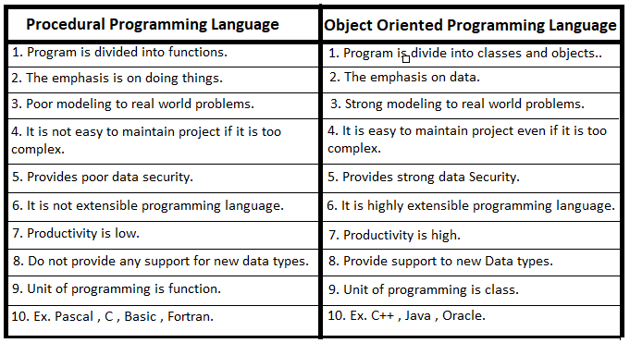

Write short notes on the following:

a) Object

All the entities of a program used in OOP method are called objects. Here entities represent a group of people, teachers, students, books, cars, etc. Each entity or object does have an attribute called characteristics and the behavior or functions. For example, a car can be an object. The colour like blue, black, size, weight, etc. are the attributes or the characteristics, which distinguishes to it with other objects and move, turn, etc. can be the functions.

b) Class

Class is a user defined data type in OOP, which defines the data types for all the objects, which run under it. Or it collects the objects of its similar data types. For example, a class vehicle can have the objects like car, bus, truck, etc. Similarly a class school can have students, teachers, staff, etc.

c) Abstraction

It is a feature of hiding internal detail of any object. It provides only the interface to the user, which makes them easy to use but does not show the details of that object, how that works and how that is made. Due to this feature, OOP has become very secure platform for its data from being accidental alteration.

d) Encapsulation

It is a process of combining the data and functions together. OOP gives more emphasis on the data rather than the functions or procedures. Many functions can use the same data but the instruction given to the function to use any particular data and combining them together is the encapsulation. Due to its unrelated functions cannot use unnecessary data in the program.

e) Inheritance (Imp.)

Inheritance is the process of creating new classes based on the existing class. The new classes require the features of the main class called the Super class and it is provided through the feature called Inheritance. By the Inheritance feature Super class can coordinate with it’s sub classes. It models the real world. It allows the extension and reuse of existing code without having to rewrite for the new created classes.

f) Polymorphism

It is a feature of OOP, which refers to the way of operating the same operator in different ways and different method or purpose. Operator overloading and the operation overloading are the examples or Polymorphism. For example ‘+’ operator can be used for arithmetic operation and string concatenation both. This facility or feature is an example of Polymorphism. It reduces the number or keywords or operators.

**System Analyst**

The person who is involved in analyzing, designing, implementing and evaluating, computer based information system to support decision making and operation of an organization is known as system analyst. He/she is a computer specialist person who is in charge of designing, modifying and analyzing various system to ensure compatibility and user effectiveness. A system analyst used computers and related system to design new IT solution, modify, enhance, or adapt existing system and integrate new feature or improvement all with the aim of improving business efficiency and productivity. They must posses a high level of technical expertise and have depth knowledge of current business practices.

**Attributes qualities of good system analyst/desirable characteristics or qualities**

1) Knowledge of an organization: A system analyst must understand way in which various functions of an Organization. He/she should have insight view of management structure, objective of an organization and the relationship among the department in the organization. He/she should know the principle end policies of an organization for whom the information system is to be built. In general he/she should have great knowledge of business practices.

2) Communication skill: Effective communication skill is vital for the success of any system. The system analyst should have ability to articulate and speak with all levels of managerial position of an organization. He/she is required to influence people to change their mind and attitude and motivate them to work in group.

3) Technical knowledge: System analyst should have the knowledge of basic of computers and business functions. He/she must be familiar with the capabilities and limitations of hardware and software products. He/she should possess good and enough technical knowledge so that he/she can recommend and implement new information system.

4) Creativity: The analyst should be creative enough to generate ideas and views that can help different executives in decision making process and help organization to increase its efficiency and productivity. He/she should be innovate enough to design and implement new system.

5) Problem solving: System analyst should have the skill of problem solving, developing alternative solutions scheduling and co-ordinating team effort and managing cost and account. He or she should posses deep intellectual capacity, and should be able to diagnosis problem critically.

6) Dynamic interface: System analyst must be a perfect of both technical and non-technical skill. He/she should have potential of dealIng with technical issues and management function.

**Roles and responsibilities/Duties**

1) Defining requirement: It involves understanding users requirement by interviewing, finding out what information is being used and what is their expectation towards purposed system. He/she should be capable of recommending appropriate information system to solve the specific problem of two user.

2) Analyst and evaluation: The system analyst analyze the working of current information system in the organization and find out the best characteristics of existing system and evaluates if new system modification is required.

3) Gathering data facts and opinion of user: Since, System analysis may recommend information system on behalf of user so he/she should gather actual and appropriate data before recommending. His/her purpose system should fulfill the requirement of the user. Hence, proper communication between user and analyst is required to gather important ideas and opinion.

4) Prioritizing requirement: System analyst should be able to prioritize the requirement of the user that means the requirement of the user may not always be useful so he or she should be able to filter or sort out the requirement according to the priority by making communication with user.

5) Designing system: It is one of the important responsibilities of system analyst to design the system according to the requirement of the user. Designs are frame work for the development of the system. Hence, system analyst should understand the need of the user and incorporate that need in a proposed system through design.

**System Development Life Cycle (SDLC)**

System is defined as an integrations of objects of the real world environment joined in some regular interaction. The process of developing system by set of predefined steps is called system development life cycle. We need system development lifecycle due to following reasons. Computer based processing enables the same data to be processed in many ways according to the need.

* It is easier to handle large volume of data and deal with variety of information.
* It is easier to handle organization having distributed branches.

The software development lifecycle consists of following phases:

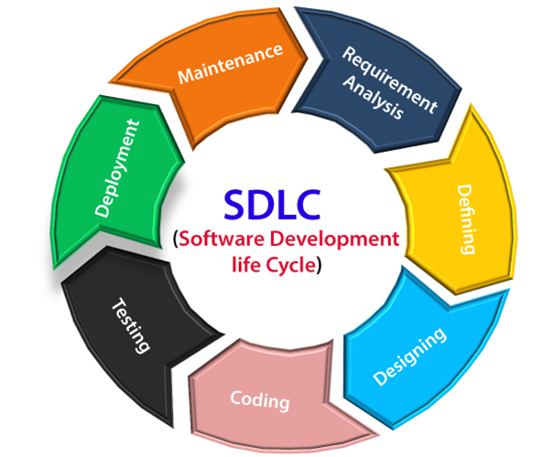

1) System investigation: It is the preliminary way of handling the user request to change, improve or enhance existing system. The objective is to determine the user requirement, whether the request is valid and feasible. In this phase, problem definition is well understood, as system intended to meet the need of an organization. Thus, the first step in the design is to specify these needs for requirements. The top manager of an organization takes the basic decision to use a computer based information system for managing the organization. During this phase the objective of the system are identified. In general system Investigation studies the following questions. What is to be done in the future?

* How to do it?
* When to do it?
* Who will do it?

2) System analysis: The process of analyzing a system and trying to find a way to modify it or create a new system to meet the users need. In other words, the investigation into system operation and possible changes to the system is called system analysis. The system are made up of many interrelated task, change to any one of this task to the addition of new task may affect the existing one. Therefore, it is necessary to understand the system and its problem which will help to reduce the failure due to any risk and uncertainties. Main activities which are undertaken in this phase.

* Definition of output requirements such as content, layout design etc.
* Specification of input data such as source, format etc.
* Development of overall logic.
* Develop step by step algorithm and flowchart.
* Develop a general test requirement

3) Feasibility studies : The process of analyzing whether the proposal is feasible or not is known as feasibility study. If it is not feasible then we have to look after other alternative. Feasibility study mainly focus on the demand of the system that affects the overall the development of the information system. Feasibility is how beneficial or practical the development of an information system will be to an organization.

The aim of feasibility study Are.

* To determine whether the objective stated can be early attainable within a prescribe limitation and period.
* To define major problem areas so that system analyst can plan the strategy for the field investigation.
* To find areas where we can save time money and effort.
* To prepare cost estimation and time scheduling.
* To discover the areas where specialist knowledge are required.

**Different types of feasibility study.**

**a**) **Economic feasibility**: The system development said to be economically feasible if the budget on proposed system doesn't ought weight, the estimated cost involve in acquiring, installing and operating it. Cost can be one time or continuing and can occur at various time during project development and use. It mainly measures cost, savings, and benefits. During economic feasibility the cost of the following things are to be measured.

* People including IT staff and user.
* Hardware and equipment
* Software
* Formal and informal training
* License and fees
* Facility cost

b) **Schedule feasibility (time)**: A system development is said to be schedule feasible if time required to accomplish the project doesn't cross the proposed deadline. It is called schedule feasibility. The schedule feasibility also depends upon available manpower and economical condition as well. In practice, time period of project completion should be always less than or equal to time required then proposed time, then only the system will be schedule feasible.

c) **Technical feasibility**: A system development is said to be technically feasible if the organization has the resources to develop or purchase, install and operate the system. It measures the availability of appropriate manpower required to accomplish the project. If the manpower used are not technical or the work performance of the technical manpower are not experienced the entire system will be certainly insufficient and this will distract the achievement of its goals and objectives, Technical feasibility measures following things.

* Does the company have the need of technical expertise? If not can it be acquired ?
* Does the company have necessary hardware, software and network resources?

d) **Operational feasibility**: A system that has operational feasibility is one that will be used effectively after it has been developed. If user have difficulty with a new system it will not produce the expected benefit. Operational feasibility depends on several issues. Some are performance of employees, information, economy, control, efficiency and service. A system which is operationally feasible will win it day to day activities smoothly without any delay and disturbance.

4) **System design**: System design is the process of creating alternative solutions to satisfy the investigated goals, evaluating the choices and drawing up the specification for the chosen alternative. Design begins after the study team has analyzed the current procedure. Since many factor have been bearing on the design process, it can be challenging. After analyzing the current system the job of the designer is to decide whether the benefits and possible savings expected from design alternative out weigh the cost. There are several designing tool. Some of them are algorithm, flowchart, ER diagram etc

**Algorithm**: The sequential system steps written in order to solve a particular problem is known as algorithm. Eg, Algorithm to find greatest number among two numbers.

Step 1: Start

Step 2: Enter any two number (a, b)

Step 3: Check whether (a>b)

If true: Go to step 4 and stop

If false: Go to step 5 and stop

Step 4: Display greatest number is ‘a’

Step 5: Display greatest number is ‘b’

Step 6: Stop

**Flowchart**: The diagrammatic representations of steps involved while solving a particular problem is called flowchart.

5) **System Development (Coding)**: Coding the process of writing programs using actual programming language. In the phase solutions are created using real program code. In general, the system design needs to be implemented to make it a workable system. This demands the coding of design into computer language i.e. programming language (machine level language, high level language, assembly language). This is also called the programming phase in which the programmer converts the program specification into computer instruction, which we refer to as program. The programs co-ordinate the data movement and control the entire process in a system. A well written code reduces the testing and maintenance effort. This helps in fast development, maintenance and future changes if required programming tools like compiler, interpreter and languages like C, C++, Java script, PHP etc are used for coding. With respect to the type of application, appropriate programming language should be chosen.

6) **System Testing** : This steps includes whether the developed system can fulfill the user requirement or not. The testing is the process of validating the correctness of program. It's objective is to demonstrate that the program meets its designed specification. It is an investigation conducted to provide stake holder with information about the quality of the product or service under test. Some of the objective of system testing are :

* To check whether developed system fulfills the user requirement or not.
* To check whether developed system works as expected.

**System Development Model**

A) **The waterfall Model**: This model is some time called classic life cycle because it suggest a systematic sequential approach to software development that begins with customer specification of requirements and progress through planning, modeling, construction etc. It is an oldest type of model for software engineering. It takes the fundamental process activities of specification, development, validation and evolution & represents them as separate process phases such as requirements specification, software design, implementation testing and so on.

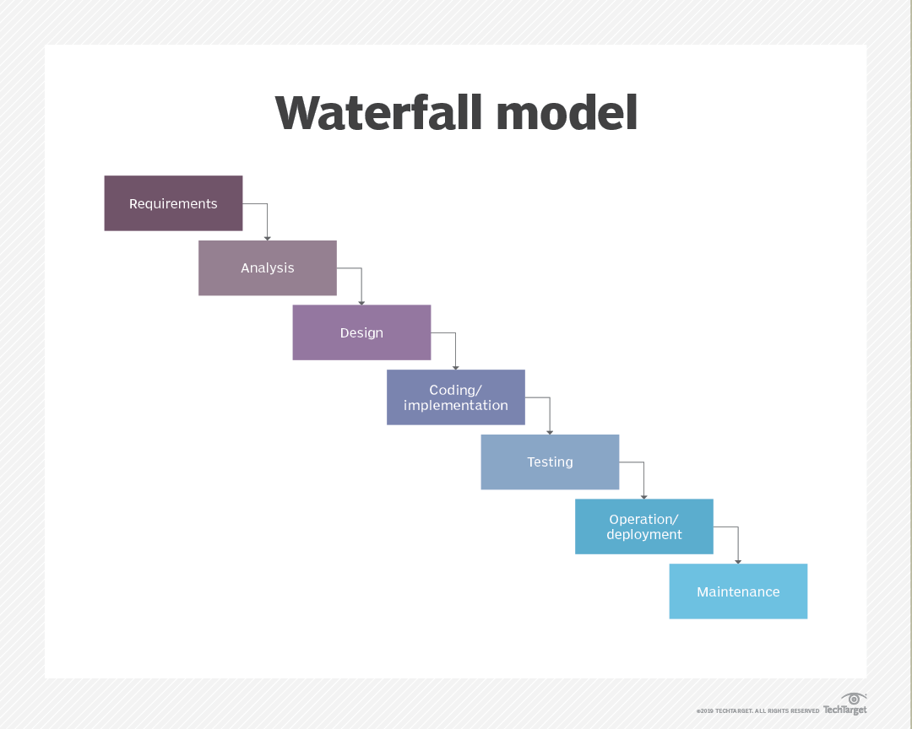

B) **Prototyping Model**: This model is applied when there is an absence of detail information regarding input and output requirement of a software. Prototype model is suitable when the requirement of the client is not clear and it is supposed to be changed. It doesn't cover any risk management.

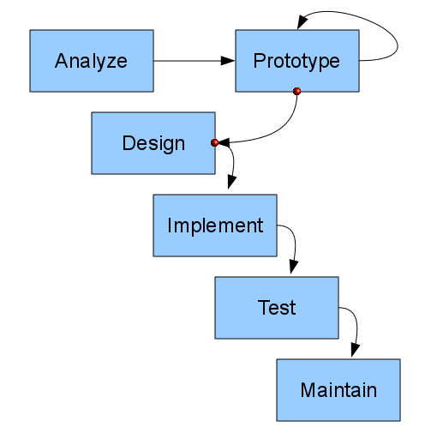

C) **Spiral model**: In this model, process is represented as a spiral rather than a sequence of activities with back tracking. Each loop in the spiral represent a phase in the process. It has no fixed phase such a specification or design. Loops in the spiral are chosen depending upon what is required. This model combines the feature of both waterfall model and prototype model. The spiral model is favorable of large, expensive and complicated projects. It is a system development method in Looping structure. In this model planning, risk analysis, software development and user evaluation are repeatedly processed until the system performed correct output.

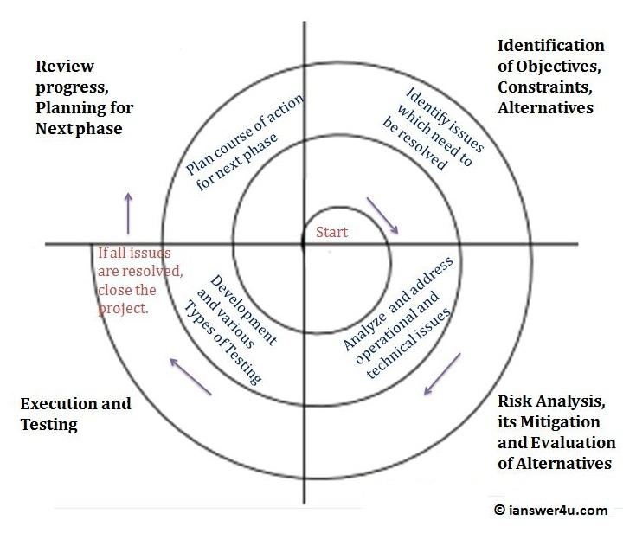

|  |  |
| --- | --- |
| **Program Flowchart** | **System Flowchart** |
| i. It gives detail of any particular part of the system. | i. It gives detail of whole system or software. |
| ii. It is limited. | ii. It is broad. |
| iii. It has less symbols. | iii. It has more symbols. |
| iv. It is easy to understand. | iv. It is difficult to understand. |
| v. It is designed by the programmer. | v. It designed by the system designer. |

**Program Flowchart**: It is the type of flowchart that explains how a particular program solves a given tasks. It helps to get an understanding on how to solve the problem using the programs· Since it solves only one type of problem at a time, it is very easy to understand. Different symbols used in program flowchart are:

**System flowchart**: A system flowchart plays vital role in system analysis. It illustrates the elements graphically and characteristics of a system, its structure and relationship in terms of flowchart symbol. A system flowchart is a diagram that shows a broad overview of the data flow and sequences of operation in a system. It is the graphical representation of a sequence of activities in a process of a system.

**UNIT 7. Recent trends in Technology**

1. **E-learning**: E-learning is the process of learning through the electronic media like computers. The concept of Distant Learning has become possible through the e-learning. One can get degree of a university through the e-learning. The CAL (Computer Assisted/Aided Learning) is an example of E-learning. Internet, Intranet, Extranet, Virtual Class room and Multimedia CD/DVD ROM are the tools used in E-learning. It has many advantages:

* · Very flexible and cheaper
* · Time saving
* · Can be read any time and any where
* · Course moves faster than traditional method
* · Uniformity of content
* · Interactive online session

2. **E-commerce**: The commerce through the use of electronic media is called E-commerce. It is the most popular and highly used advantage of IT. Replacing the traditional method of account controlling, quality and quantity controlling, money transaction, official and industrial management, etc. by the computers and electronic machines are some popular concepts of E-commerce. There are basically three types of E-commerce:

i. Business-to-Business

ii. Business-to-Customer

iii. Digital Middle Man

3. **E-Business**: The process of performing business activities through the electronic media, especially Internet is called E-Business. It includes selling, buying and servicing customers and collaborating with the business partners, too. It uses web-based technology for the advertisements and for the improved business performance. Some examples of this system are ebay, amazon, Alibaba etc

4. **E-Governance**: The process of governing through the use of Electronic media is called E-Governance. The traditional governing system cannot reach to the remote or rural area and it cannot address the actual problem of them. It is centered in the urban area. So, the E-Governance has become a popular concept of governing. It uses electronic media like Internet, Intranet, Wireless Phone, E-voting, E-commerce, E-health service and E-education, etc to address the problem of the people. It increases the speed of working of Government. The following are the E-Governance models:

i. Government to Citizens (G2C)

ii. Government to Employees (G2E)

iii. Government to Government (G2G)

iv. Government to Business (G2B)

In other word, The way of performing governmental activities through internet. For instant, every citizen has to perform their daily governmental activities such as birth registration, tax payment, utilities bill payment etc. If these governmental activities are done through electronic means and media then, it is known as e-government. The major objective of e-government is to increase accountability, transparency, efficiency and which helps to reduce corruption.

**Challenges of E-government:**

a. IT literacy

b. Lack of coordination

c. Training

d. IT Policy

**Importance of E-government.**

a. Promote awareness and dramatically improves the efficiency of the civil services.

b. It will encourage public participation.

c. It will create healthy business environment.

d. It increases accountability, transparency, efficiency and which helps to reduce corruption.

e. It allows to share knowledge and information between organization easily.

5. **E-Medicine**: Electronic medicine is a service of E-Government, which provides E-health services to the people. The use of computers for diagnosis of diseases, operations and research of medicine are the examples of E-Medicine. The way of performing medical activities through electronic means and media are e-medicine. Now a days, there are significant roles of modern tools and technologies in the field of medicine. For eg, Technologies such as X-rays, CT scan etc are used to diagnosis several critical diseases and illness. There are several websites which are particularly targeted toward medicine. These websites help user to find out the required information about their queries. One can check the health condition using electronic means and media.

**Pros**

a. Distance medical facilities can be provided to remote area.

b. Drones can be used to supply medical equipment in needy area with in less time.

c. Remote counseling is possible through e-medicine.

d. Different high-tech tools and devices are used to diagnose several critical illnesses.

6. **Virtual Reality**: It is an artificial environment created by using the computers, which tries to give natural environment of the presentation. It creates an illusion of the real world. Head Mounted Display (HMD), Binocular Omni Oriented Monitor (BOOM) and Cave Automatic Virtual Environment (CAVE) are some common devices used for Virtual Reality. It is very popular in the fields of entertainment, space and civil aviation.

7. **Robotics**: It is the term used for the designing, constructing and using robots in various purposes. The term ‘robot’ was first used by Karel Capek in his play Rossum’s Universal Robots, published in 1920. Scientists are trying to give the human-like intelligence to the robots, so that they understand the natural languages and they can be able to interact with the humans to assist them. Transportation, exploration, surgery, bomb diffusion, etc. are some popular application of robots. They are especially used in the areas, which are full of risk.

8. What is AI? Write the uses of it.

AI stands for Artificial Intelligence. It is a concept of giving human-like intelligence to the machines. Though the computers do their work faster and better than the human beings, the intelligence of them is zero because they just follow the set of instructions given by the user. In case of wrong instruction, they do wrong processing. It is because they do not have intelligence of their own. So, the scientists are in research of giving them artificial intelligence, so that they can understand the natural languages of the human beings and interact. They can express their feelings and many more. These are some common uses of AI:

i. Game Playing

ii. Diseases Diagnosis & Operations

iii. Robotics

iv. Problem Solving

v. Speech and pattern Recognition

vi. Expert System

vii. Theorem Proving

viii. Machine Learning

9. What is the ethical aspect of AI?

In accordance of AI, the machines get the human-like intelligence. Till now, the difference between the human beings and the machines is that they do not have intelligence of their own. They depend upon the human instructions. But after they get their intelligence, they can interact with the human and the question has been raised, do they follow the human-instruction? If not, what to do? Do they work under human control? What happens, if they did not follow the human instructions? What, if they go out of control from the human race? What happens in the society? These are some ethical aspect of AI. Similarly, the machine replacement in place of the human can cause the frustration and moral down to the human race.

**Programming Solutions**

**1. Write a program to find given number is even or odd using C program .**

Solutions:

#include<stdio.h>

int main(){

int a;

printf("Enter a number to know it is evenr or odd

\n");

scanf("%d",&a);

if(a%2==0){

printf("%d is even number",a);

}

else{

printf("%d is odd number",a);

}

return 0;

}

**2.Write a program to print whether a given number is prime or composite number .**

Solutions:

#include<stdio.h>

int main(){

int a;

printf("Enter a number to check \n");

scanf("%d",&a);

int b;

int c=0;

for(b=1;b<=a;b++){

if(a%b==0){

c=c+1;

}

}

if(c==2){

printf("It is prime number");

}

else{

printf("It is composite number");

}

return 0;

}

**3. Write a program to print multiplication table of given number using C program.**

Solutions:

#include<stdio.h>

void main()

{

int a=1,b,c;

printf("Enter a number to find table:");

scanf("%d",&b);

do{

c=b*a;

printf("%d * %d = %d \n",b,a,c);

a++;

}

while(a<=10);

}

**4. Write a to display fibonacii series using C program with functions.**

Solutions:

#include<stdio.h>

void fibonacciSeries(int range)

{

int a=0, b=1, c;

while (a<=range)

{

printf("%d\t", a);

c = a+b;

a = b;

b = c;

}

}

int main()

{

int range;

printf("Enter range: ");

scanf("%d", &range);

printf("The fibonacci series is: \n");

fibonacciSeries(range);

return 0;

}

**5. Write a program to print prime numbers between 1 to 100 .**

Solutions :

#include<stdio.h>

int main(){

int a;

int b;

int c;

printf("Prime number from 1 to 100 :");

for(a=1;a<=100;a++){

c=0;

for(b=1;b<=a;b++){

if(a%b==0){

c++;

}

}

if(c==2){

printf("\n%d",a);

}

}

return 0;

}

**6. Write a program to find factorial of given number using recursive function.**

Solutions:

#include<stdio.h>

#include<conio.h>

int fact(int);

void main(){

int n,f;

printf("Enter no. for finding factorial :");

scanf("%d",&n);

f=fact(n);

printf("factorial is %d",f);

getch();

}

int fact(int n){

if(n==0){

return(1);

}

else{

return(n*fact(n-1));

}

}

7.**Write a program to find sum of given ‘n’ numbers in array using function .**

Solutions :

#include <stdio.h>

int sumofarray(int a[],int n)

{

int i,sum=0;

for(i=0; i<n; i++)

{

sum+=a[i];

}

return sum;

}

int main()

{

int a[1000],i,n,sum;

printf("Enter size of the array : ");

scanf("%d", &n);

printf("Enter number to do sum : ");

for(i=0; i<n; i++)

{

scanf("%d",&a[i]);

}

sum=sumofarray(a,n);

printf("sum of array is :%d",sum);

}

**8. Write a display to Sunday to Saturday when user enters a number using switch case in c program .**

Solutions :

#include <stdio.h>

int main() {

int a ;

printf("Enter a day number\n");

scanf("%d",&a);

switch(a){

case 1 : printf("This means Sunday");

break;

case 2: printf("This means Monday");

break;

case 3: printf("This means Tuesday");

break;

case 4: printf("This means Wednesday");

break;

case 5 :printf("This means Thursday");

break;

case 6:printf("This means Friday");

break;

case 7: printf("This means Saturday");

break;

default: printf("This is Invalid number");

}

return 0;

}

9. **Write a program to find power using pow() function in c .**

Solutions :

#include<stdio.h>

#include<math.h>

int main()

{

int num1, num2;

printf("Enter base and power: ");

scanf("%d %d",&num1, &num2);

printf("Result = %.2f",pow(num1, num2));

return 0;

}

**10. Write a c program to find greatest number among different numbers using array with functions .**

Solutions :

#include<stdio.h>

void main()

{

int maximum(int a[],int n);

int max,i,n;

int a[50];

printf("Enter how many no. to check:");

scanf("%d",&n);

printf("Enter the numbers:\n");

for(i=0;i<n;i++)

{

scanf("%d",&a[i]);

max=maximum(a,n);

}

printf("The largest number is %d",max);

}

int maximum(int a[],int n)

{

int i,m=0;

for(i=0;i<n;i++)

{

if(a[i]>m)

m=a[i];

}

return m;

}

1**1. Write a c program to find whether a given number is plaindrome or not .**

Solutions:

#include <stdio.h>

int main() {

int n;

int original;

int remainder;

int reversed=0;

printf("Enter an integer: ");

scanf("%d", &n);

original = n;

while (n != 0) {

remainder = n % 10;

reversed = reversed * 10 + remainder;

n /= 10;

}

if (original == reversed)

printf("%d is a palindrome.", original);

else

printf("%d is not a palindrome.", original);

return 0;

}

**12. Write a c program to find whether a given string is plaindrome or not .**

Solutions :

#include<stdio.h>

#include<string.h>

int main()

{

char s1[1000],s2[1000];

printf("Enter the string: ");

gets(s1);

strcpy(s2,s1);

strrev(s2);

if(!strcmp(s1,s2))

printf("string is palindrome");

else

printf("string is not palindrome");

return 0;

}

**13. Write a c program to input 2*2 matrix element and display the transpose of matrix.**

**Solutions:**

#include<stdio.h>

void main()

{

int mat[2][2],transpose[2][2];

int i;

int j;

printf("Transpose of 2*2 matrix\n");

printf("Enter the elements of the matrix\n");

for(i=0;i<2;i++)

{

for(j=0;j<2;j++)

{

scanf("%d",&mat[i][j]);

}

}

printf("The matrix\n");

for(i=0;i<2;i++)

{

for(j=0;j<2;j++)

{

printf("%d\t",mat[i][j]);

}

printf("\n");

}

for(i=0;i<2;i++)

{

for(j=0;j<2;j++)

{

transpose[j][i]=mat[i][j];

}

}

printf("The transpose of the matrix is\n");

for(i=0;i<2;i++)

{

for(j=0;j<2;j++)

{

printf("%d\t",transpose[i][j]);

}

printf("\n");

}

}

**14.WAP to enter the 20 employee’s name, age, and salary using structure**

**and print them.**

Solutions :

#include<stdio.h>

struct emp

{

char n[100];

int age;

int sal;

};

struct emp e[20];

int main()

{

int i;

printf("Enter employee name age and salary\n");

for(i=0;i<20;i++)

{

scanf("%s %d %d",e[i].n,&e[i].age,&e[i].sal);

}

printf("Name \t Age \t Salary");

for(i=0;i<20;i++)

{

printf("%s\t %d\t %d\t",e[i].n,e[i].age,e[i].sal);

}

return 0;

}

**15. Write a c program to find whether a given number is Armstrong or not .**

**Solutions:**

#include<stdio.h>

int isArmstrong(int number)

{

int lastDigit = 0;

int power = 0;

int sum = 0;

int n = number;

while(n!=0) {

lastDigit = n % 10;

power = lastDigit*lastDigit*lastDigit;

sum += power;

n /= 10;

}

if(sum == number) return 0;

else return 1;

}

int main()

{

int number;

printf("Enter number: ");

scanf("%d",&number);

if(isArmstrong(number) == 0)

printf("%d is an Armstrong number.\n", number);

else

printf("%d is not an Armstrong number.", number);

return 0;

}